BEGINNING

EXERCISE 9.2 – Syntactical structure

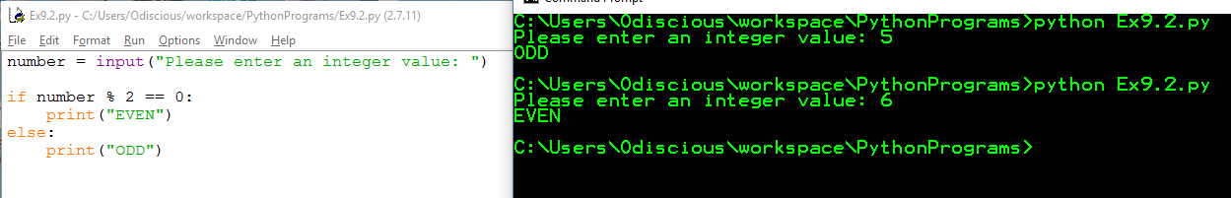

EXERCISE 9.3

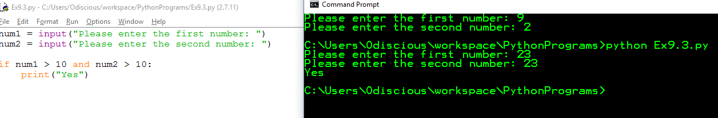

EXERCISE 10.2

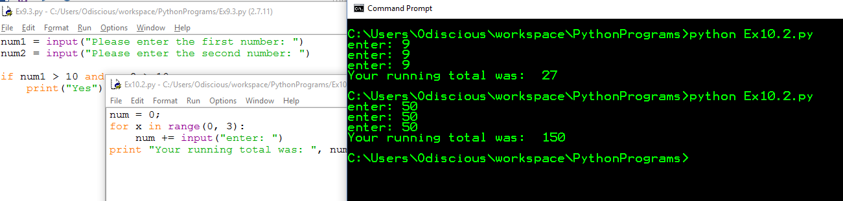

EXERCISE 10.3 Python doesn’t support ++

